Synthesis of the Akerberg-Mossberg biquad
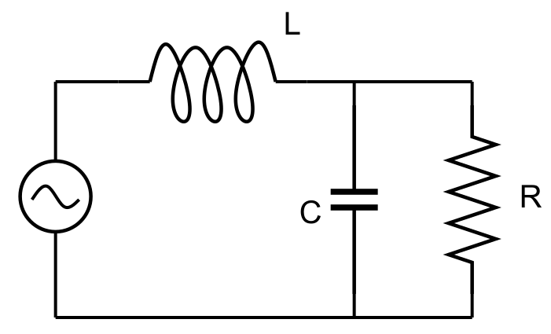
Let’s start with the prototype filter
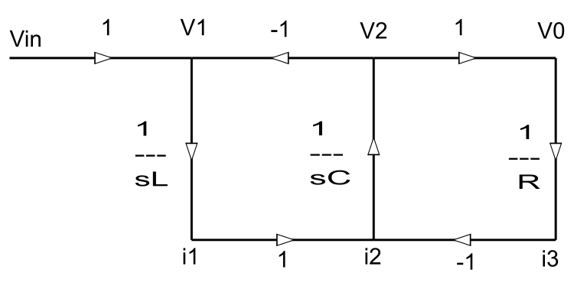
Multiply/divide each branch by R to convert currents to voltages
Using flow graphs
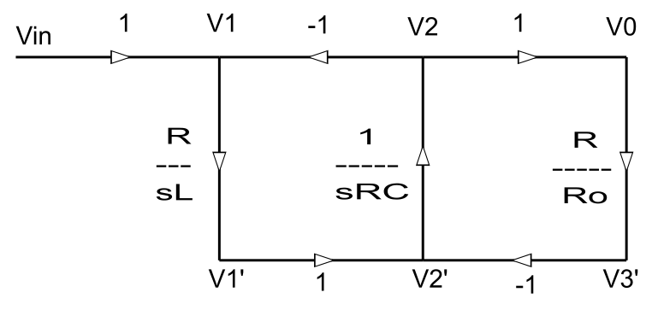
Synthesis of integrator 1
$$V_{1}=Vin-V_{2}$$

$$V_{1}^{'}=V_{1}∙\frac{R}{sL}=V_{1}∙\frac{1}{s\frac{L}{R}}=V_{1}\frac{1}{sRC_{1}}$$

$$\frac{L}{R}=RC_{1}→C_{1}=\frac{L}{R^{2}}$$
$$V_{1}'=\left(Vin-V_{2}\right)\frac{1}{sRC_{1}}$$

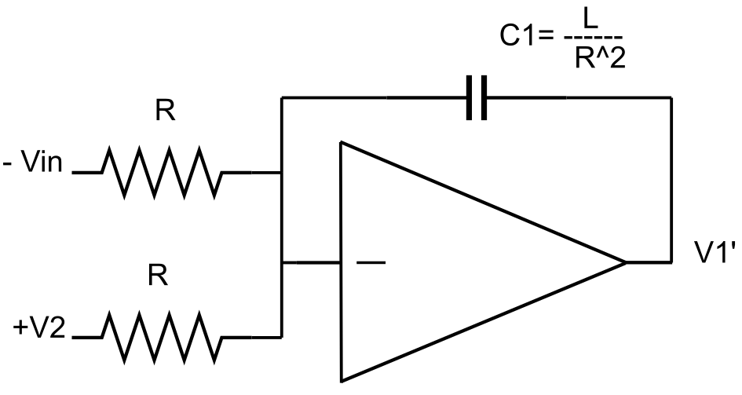
Synthesis of integrator 2
$$V_{2}^{'}=V_{1}^{'}-V_{3}' Vo=V_{2}$$
$$V_{2}=V_{2}'∙\frac{1}{sRC}=\left(V_{1}'-V_{3}'\right)\frac{1}{sRC}$$
$$V_{3}'=Vo\frac{R}{Ro}=V_{2}\frac{R}{Ro}$$
$$V_{2}=\left(V_{1}'-V_{2}\frac{R}{Ro}\right)\frac{1}{sRC}=V_{1}'\frac{1}{sRC}-V_{2}\frac{1}{sRoC}$$
$$→Vo=V_{2}=V_{1}'\frac{1}{\frac{R}{Ro}+sRC}=V_{1}'\frac{Ro}{R}∙\frac{1}{1+sRoC}$$

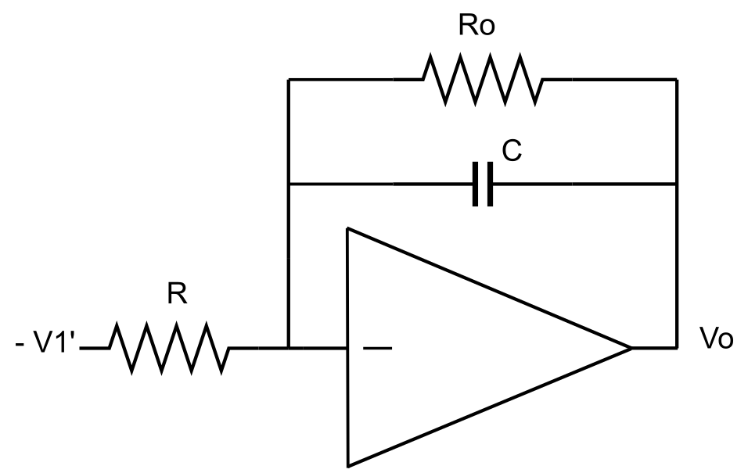
Frequency response calculation
General case (Butterworth, Chebyshev type I, Bessel)
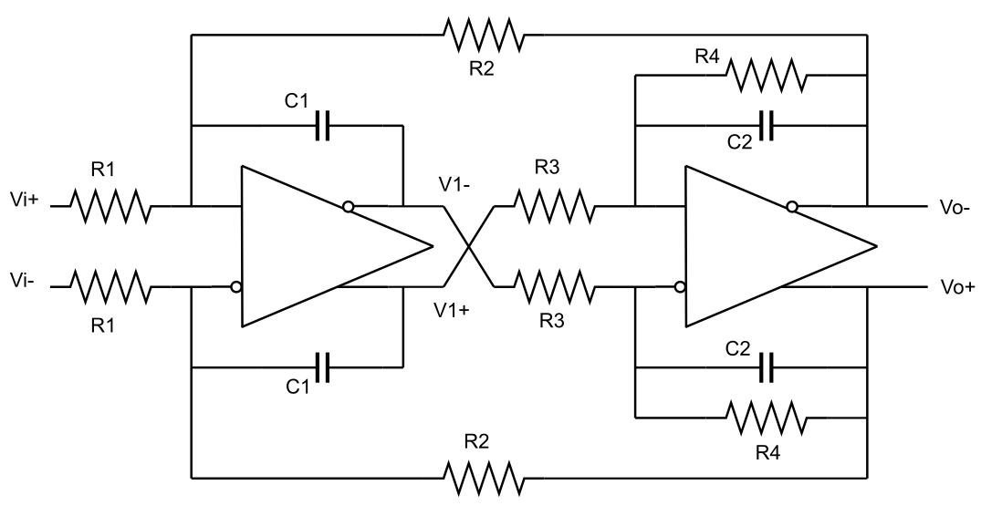

$$V_{1}=V_{i}\frac{1}{sR_{1}C_{1}}-Vo\frac{1}{sR_{2}C_{1}}$$
$$Vo=V_{1}\frac{R_{4}}{R_{3}}\frac{1}{1+sR_{4}C_{2}}→V_{1}=Vo\frac{R_{3}}{R_{4}}\left(1+sR_{4}C_{2}\right)$$
Equaling V1 values in both equations
$$Vo\frac{R_{3}}{R_{4}}\left(1+sR_{4}C_{2}\right)=V_{i}\frac{1}{sR_{1}C_{1}}-Vo\frac{1}{sR_{2}C_{1}}$$
$$→\frac{Vo}{V_{1}}=\frac{1}{sR_{1}C_{1}}\frac{1}{\frac{R_{3}}{R_{4}}\left(1+sR_{4}C_{2}\right)+\frac{1}{sR_{2}C_{1}}}$$
$$→ H\left(s\right)=\frac{Vo}{V_{i}}=\frac{1}{R_{1}R_{3}C_{1}C_{2}}∙\frac{1}{s^{2}+s\frac{1}{R_{4}C_{2}}+\frac{1}{R_{2}R_{3}C_{1}C_{2}}}$$
At DC
$${\left.H\left(0\right)=\frac{Vo}{V_{i}}\right|}_{DC}=\frac{R_{2}}{R_{1}}$$

Frequency response calculation
Imaginary zeroes case (elliptic, Chebyshev type II)
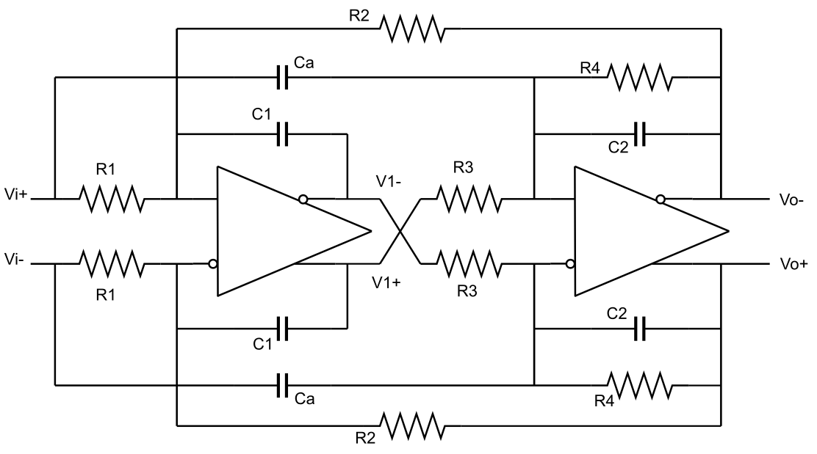
After some manipulations (similar to the case described in Appendix II) we get
$$H\left(s\right)=\frac{C_{a}}{C_{2}}\frac{s^{2}+\frac{1}{R_{1}R_{3}C_{1}C_{a}}}{s^{2}+s\frac{1}{R_{4}C_{2}}+\frac{1}{R_{2}R_{3}C_{1}C_{2}}}$$
At DC
$$H\left(0\right)=\frac{R_{2}}{R_{1}}$$

Some basics

A two complex pole transfer function is defined as:
$$H\left(s\right)=\frac{Vo}{Vi}=\frac{1}{As^{2}+Bs+C}=\frac{Kω_{0}^{2}}{s^{2}+s\frac{ω_{0}}{Q}+ω_{0}^{2}}$$Either the numerator (zeroes) or the denominator (poles) polynomials can be decomposed into their roots.
In the complex plane each pole has the form
$$p=Re\left(p\right)+Im\left(p\right)$$
$$→ω_{p}=\sqrt{{Re}^{2}\left(p\right)+{Im}^{2}\left(p\right)}$$
$$σ_{p}=Re\left(p\right)$$
$$s^{2}+bs+c=s^{2}+s∙2Re\left(p\right)+p\overline{p}=s^{2}+s∙2Re\left(p\right)+\left({Re}^{2}\left(p\right)+{Im}^{2}\left(p\right)\right)$$
$$b=\frac{ω_{0}}{Q} →Q=\frac{\sqrt{c}}{b}=\frac{1}{2}\frac{\sqrt{p\overline{p}}}{Re\left(p\right)}=\frac{1}{2}\frac{\sqrt{{Re}^{2}\left(p\right)+{Im}^{2}\left(p\right)}}{Re\left(p\right)}=\frac{1}{2}\sqrt{1+\frac{{Im}^{2}\left(p\right)}{{Re}^{2}\left(p\right)}}$$

Extracting the Q value
$$kω_{0}^{2}=\frac{1}{R_{1}R_{3}C_{1}C_{2}}$$
$$\frac{ω_{0}}{Q}=2Re\left(p\right)=\frac{1}{R_{4}C_{2}}$$
$$ω_{0}^{2}=\frac{1}{R_{2}R_{3}C_{1}C_{2}}$$
$$→Q=R_{4}\sqrt{\frac{1}{R_{2}R_{3}}\frac{C_{2}}{C_{1}}}$$

